
City & Financial Conferences
8 Westminster Court
Hipley Street
Old Woking
GU22 9LG
Tel 44 (0) 1483 720707
FAX 44 (0) 1483 757 824
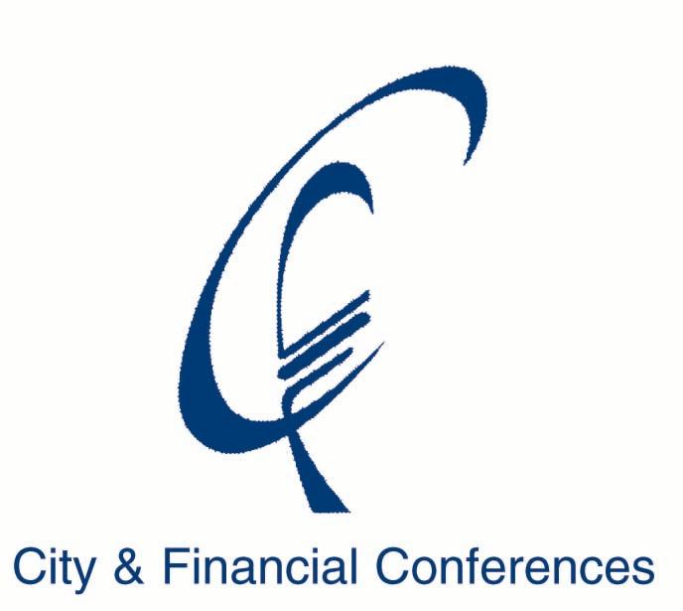

PRESS RELEASE

ISLAMIC FINANCIAL SERVICES BOARD HOLDS INAUGURAL SUMMIT IN LONDON

Professor Rifaat A. Abdel Karim, Secretary – General, of the Islamic Financial Services Board (IFSB) announced the inauguration of the its annual Summit which will take place on 18-19 May 2004 at Park Lane Sheraton Hotel in London. He said “The Summit will address the regulatory issues that affect both Islamic financial institutions and their counterparts in the West that want to offer Shari’a-compliant products for Muslim communities in the non-Islamic world.”

He added “We have drawn together an excellent panel of speakers who will discuss in detail the regulatory issues that need to be addressed by Western and Islamic regulators when dealing with institutions offering Shari’a-compliant financial products. This is the first time such a major event has been held, particularly at a time of increased need for regulatory oversight and of increased demand for these products.”

The confirmed chairmen and speakers include:
H.E. Burhanuddin Abdullah, Governor, Bank Indonesia and Chairman, Council of the IFSB
H.E. Dato Paduka Haji Yakub Abu Bakar, Deputy Minister of Finance, Brunei
H.E. Tan Sri Dato' Dr. Zeti Akhtar Aziz, Governor, Bank Negara Malaysia
H.E. Abdulla Khalid Al-Attiya Governor, Qatar Central Bank
H.E. Dr. Sabir Mohamed Hasan, Governor, Bank of Sudan
Ruth Kelly MP, Financial Secretary to the UK Treasury
Malcolm D. Knight, General Manager, Bank for International Settlements
RT Hon. Sir Edward George, Former Governor, Bank of England
Sir Howard Davies, Director, London School of Economics and Political Science, UK and former Chairman of Financial Services Authority, UK
Ryozo Himino, Secretary General, Basel Committee on Banking Supervision
H.E. Dr. Ahmad Jachi, First Vice Governor, Central Bank of Lebanon
Dato' Mohamed Razif Abdul Ghani, Chairman of IFSB Technical Committee and Assistant Governor of Bank Negara Malaysia
Stefan Ingves, Director, Monetary and Financial Systems Department, IMF
Dr. Mohsin Khan, Director, Middle East and Central Asia Department, IMF
Michael Foot, Managing Director, Deposit Takers & Markets Directorate, FSA, UK
Professor Rifaat Ahmed Abdel Karim, Secretary-General, Islamic Financial Services Board
Zarinah Anwar, Deputy Chief Executive, Securities Commission, Malaysia
Professor Simon Archer, University of Surrey, UK
Ian Ball, Chief Executive, International Federation of Accountants
Gerard Caprio, Director, Financial Sector Operations and Policy Department, The World Bank
Professor Jonathan Charkham, Former Chief Adviser to the Governor, Bank of England
Stella Cox, Managing Director, Dawnay, Day Global Investment Limited
Dr. Yusof Talal DeLorenzo; CEO, Malfa Inc, USA
Wafik Grais, Senior Advisor, Financial Sector Global Partnership Group, World Bank
Elham Hassan, Country Senior Partner, PricewaterhouseCoopers, Bahrain
Andrew Hilton, Chief Executive, Centre for the Study of Financial Innovation
Michael J.T. McMillen, Partner, King & Spalding LLP, London
Khalid Mirza, Manager, Finance and Private Sector, East Asia Region, World Bank
Luigi Passamonti, Senior Advisor, International Monetary Fund
Stephen Roughton-Smith, Managing Director, Structured Finance EMEA, Moody's Investors Service Limited
Henry Thompson, Executive Director, Legal, First Islamic Investment Bank, Bahrain

The Summit will address the following regulatory and supervisory topics and issues:
- Approaches to Regulation of Islamic Financial Services Industry and the Role of the IFSB
- Implementation of Specific Regulatory Framework in Islamic Financial Centres
- Perspective on the Regulation of Islamic Financial Institutions in Non-Islamic Environment
- Standards and Codes of Corporate Governance for the Islamic Financial Services Industry
- Enhancing Transparency and Market Discipline in the Islamic Financial Services Industry
- Basel II and Islamic Financial Institutions
- Issues of Risk Management and Liquidity in Islamic Financial Institutions
- Legal Environment Governing Islamic Finance
- Islamic Capital Markets: Government and Private Offerings
- The Challenges Ahead

Further details on the event is available on the official website for the Summit at http://www.ifsbsummit.com

For more information contact:
Nick Noakes, City & Financial, 8 Westminster Court, Hipley Street, Old Woking GU22 9LG. Tel: + 44 (0) 1483 746006. Fax: + 44 (0) 1483 740401. Email: nnoakes@cityandfinancial.com
Marlin Mohd Faroque, Islamic Financial Services Board, 3rd Floor Block A, Bank Negara Malaysia Building, Jalan Dato’ Onn, 50480 Kuala Lumpur, Malaysia. Tel: + 603 2698 4248. Fax: +603 2698 4280. Email: marlin@ifsb.org

Editors Note
The Islamic Financial Services Board (IFSB) is an association of central banks, monetary agencies and inter-governmental international organizations that has an explicit mandate for promoting Islamic financial services. Based in Kuala Lumpur, the IFSB sets and disseminates prudential and supervisory standards and core principles that are in compliance with Shari’a rules and principles for the regulation and supervision of the Islamic financial services industry worldwide. For more information on IFSB visit: http://www.ifsb.org

